

LINUX INTERVIEW QUSTIONS:

How to break the root password?

What is use of AWK ,SED did you ever used this command in your script? What is the full form GREP?
How to write the program to go to the parent directory with out using CD command? What are the run levels and explain all the run levels?
What is dierence between unix and linux?

How to nd the last exequted command in linux? How to dene the aaray in shell script?
What is use of the READ command in shell?

How to insert values in 3rd line of the le using shell script? What is di between !" # "$ commands in linux?
How to nd the port information in linux? for &" and '(" protocals?

ANT INTERVIEW QUESTIONS:

How to generate WAR le in ant?

How you will dene class path variable in ant? What is the command for exeqution in ant?
SVN&GIT INTERVIEW QUESTIONS?

What is di between $)* # +,? What is di between +, # +, H'-? What is the stashing in +,?
What is git rebase?

How to resolve merge concts in svn? What is clone in git?



JENKINS INTERVIEW QUESTIONS?

How you will create slave in .enkins? What is pipeline in .enkins?
How to schedue .obs in .enkins? How to ne the errors in .enkins?
What is toughest task you have faced in .enkins? What is di between schedule .obs # poll scm?
,f you have / .obs can we run some .obs in window slave and some .obs in linux slave? What is the use of the .enkins?
PUPPET INTERVIEW QUESTIONS?

What is use of the 01&2 tool in puppet? What is location of $$4 puppet?
What is the location of cong le in puppet? What is the use of the puppet?
What is manifest? what is modules?

GENEREL QUESTIONS?

What is devops? Why devops? What is agile methodology?
2xplain ,,4 process?

What is toughest task you have ever faced? 2xpalin about any could technology?
1re you using nexus artifactory?

How you will change port information in tomcat server? &an you depoly multiple services in tomcat?
What is di between between webserver and application server?



Interview questions


- Tell me about technical background?
- What is inventory fle?
A) It follows the INI format and tell ansible whether the remote host or host provided by the user are genuine execution or not. Ansible can run its tasks against multiple hosts in parallel. For such parallel execution ansible allows you to group your hosts in the inventory !le the pile passes the group name ansible.
. What is !" in shell?
A) " we can declare the variable "code commenting purpose.
#. $ow to create %ob?
  - #ne the $enkins dashboard click on mange $enkins and select manage plugins
  - %lick the checkbox and click on the bu&on download now and install a'er restart
  - (estart $enkins
  - %reate a new freestyle proect
  - %on!gure git in source code management section.
&. Where we can de'loy?
A) *omcat server
(. Which web server your using?
A) tomcat
). What are all web a''lications server?
● +lass !sh
  - $boos ,nterprise application pla-orm
  - ild/y
  - Apache tomcat
  - Apache tome
  - $onA0
  - (esin servlet container 1open source)
  - 2la3ix
*. Which server we can use +or web a''lication?
  - $boss ,nterprise application pla-orm
  - Apache tomcat
  - Apache tom,,
,. What is the di-erence web a''lication and stranded a''lication?
A) #n a !rst hand a web server serves web content 14*56 and static content) over the 4**7 protocol. #n the other hand an a''lication server is a container upon which you can build and expose business logic and processes to client applications through various protocols including 4**7 in a n8tier architecture.
1. What is the web server / a''lication server?
- In a''lication server which a''lication your use static or dynamic?
15 In computer terminology dynamic usually means capable of action and9or change while static means
!xed. 2oth terms can be applied to a number of di:erent types of things such as programming languages 1or components of programming languages) eb pages and a''lication programs.
- In static a''lication would change 0 name?
A) we can;t change the <(6 because of its static and !xed.


1. What is the 'eriodical and what 'oll 345?
A) 7oll 0%5 periodically polls the 0%5 to check whether changes were made 1i.e. new commits) and builds the proect if new commits where pushed since the last build whereas build periodically builds the proect
periodically even if nothing has changed.
1#. 6nce build will create which flls are create?




A) A'er completion of build .war !les will create
1&. 7id you o'en .war fles?
A) e can;t open .war !les
1(. What is the 'laybook and cookbooks?
A) #ne or more plays we can call playbooks cookbooks is combination of recipes and a&ribute !le distribution templates we can called as cookbook
- Who will create source code / 'om fles?
89 0ource code will create by developers and pom !les they will create why they create means they know source code workspace and class !le and everything
1*. Why 'om fle? What is the use o+ 'om fle?
15 7roect #bect 5odel or 7#5 is the fundamental unit of work in 5aven. It is an =56 !le that contains information about the proect and con!guration details used by 5 aven to build the proect. It contains default values for most proects.
1,. What is docker?
89 >ocker is a tool designed to make it easier to create deploy and run application by using containers.
%ontainers allow developer to package up an application with all of the parts in needs such as libraries and other dependencies and ship it all out as one package. 2y doing so thanks to the container the developer can rest assured that the application will run on any other linux machine regardless of any customi3ed setting that machine might have that cloud di:er from the machine used for writing and testing the code.
2. What is environment in docker?
- Why docker we can use?
A) >ocker provides this same capability without the overhead of a virtual machine. It lets you put your environment and con!guration into code and deploy it. *he same >ocker con!guration can also be used in a variety of environments. *his decouples infrastructure re@uirements from the application environment.
- $ow would you create environment?
2. :enkins will work on inu; only?
A) $enkins will work on linux and window and cloud environment.
2#. $ow to create nodes in :enkins?
A) #pen $enkins dash board select manage $enkins under that select manage nodes click on new node a'er that give the workspace path and node con!guration.
2&. $ow to create works'ace +or build fles in :enkins?
2(. What is the scm tool?
A) 0cm source code management tools it are git git hub svn.
- What 4I tool?
A) $enkins bamboo team city.
2*. What are all build tool?
A) Ant maven
2,. What is yaml fle?
A) A56 stands for BA56 AinCt 5arkup 6anguageB and it is used extensively in +rav for its
con!guration !les blueprints and also in page settings. A56 is to con!guration what markdown is to markup. ItCs basically a human8readable structured data format At its core a A56 !le is used to
describe data.
2,9 What is merge in git?
89 (2$&,",!*6 ,ncorporates changes from the named commits 7since the time their histories diverged from the current branch5 into the current branch6 his command is used by git pull to incorporate changes from another repository and can be used by hand to !rg! changes from one branch into another6
9 $ow to do build?




89 +o to J!"#i"$ top page8 select 9*ew :ob98 then choose 9 %i'( a free;style so<ware pro.ect96 his .ob type consists of the following elements= optional $&>8 such as &)$ or $ubversion where your source code resides6 optional triggers to control when J!"#i"$ will )!r*+r i'($
19 $ow to do de'loy?
29 <ariable in che+?
9 $ow to create %ar fles?
89 #nce build will run ar !les will create in work space
#9 $ow to create build fles in maven?
&9 7e'loyment tools?
(9 $ow to create build confguration +or git hub?
)9 7i-erence between maven u 'ro%ect and 'i'eline 'ro%ect?
- 1 maven pro.ect is a pro.ect that will analye the pom6xml le in greater detail and produce a pro.ect that@s geared towards the targets that are invoked6 he maven pro.ect is smart enough to incorporate build targets like the :avadoc or test targets and automatically setup the reports for those targets6
- 1 0ree;$tyle pro.ect is a pro.ect that can incorporate almost any type of build6 While a maven
pro.ect you can only build maven pro.ects8 the 0ree;$tyle pro.ect is the more 9generic9 form of a pro.ect6 Aou can execute shellBdos scripts8 invoke ant8 and a lot more6 >a.ority of the plugins are wriCen to use the free;style pro.ect6 he maven module is limited in that it can@t invoke a shell script8 or anything else .ust the maven targets6

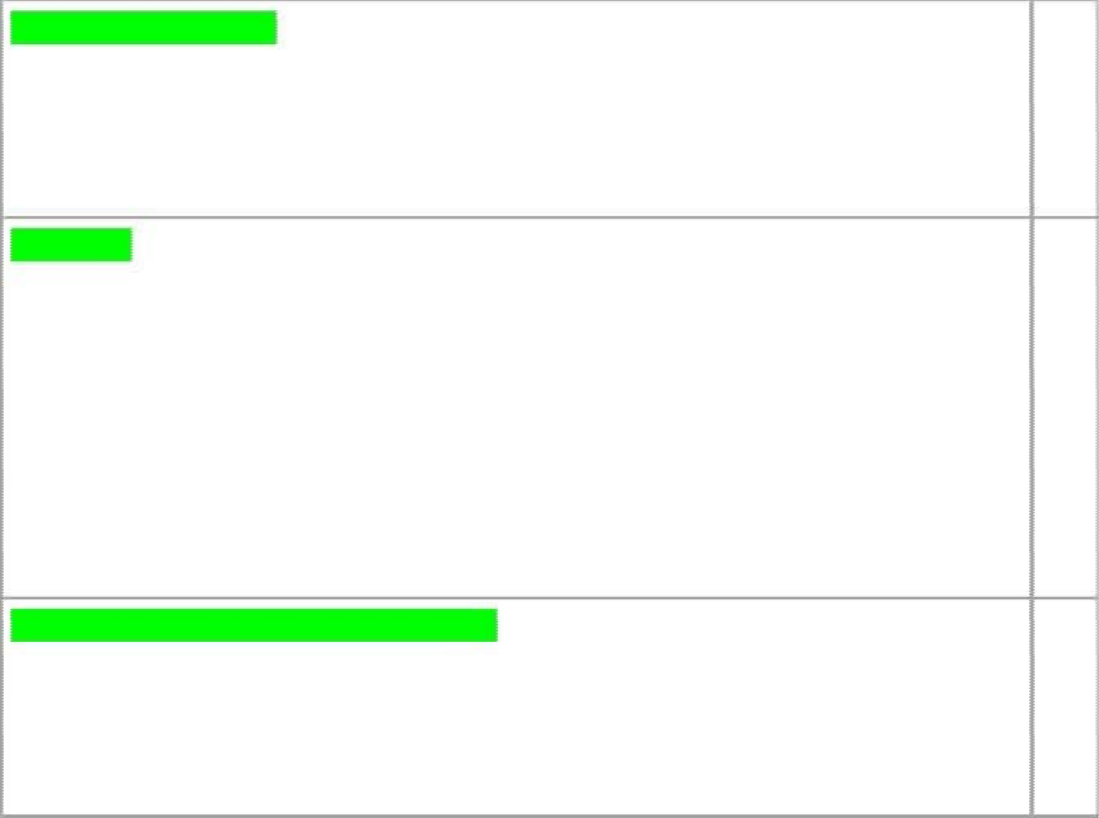
What do mean by -uild? D
-uild is nothing but compiling of sources in to distributed artifacts6 $o developers will be writing the source code666and it needs to be compiled and packaged so then it can be distributed to the customers or users for using it66666 $o this build might be happening so a<er development6666it can happen during development or it can happen in a periodic basis like every week or every month666

What is &,? E
&, is nothing but a so<ware development practise where members of each team integrate their work daily6666by integrating their work daily8 they can test it every day and it reduces the problems and it can identify the problems earlier and they can x it earlier666then we can make product more stable666 hat is the main use of &, 6666,f we start the building at the end of the pro.ect we will identify so many issues8 those are integration issues because code will be developed by the multiple developers66666if we start integrating them daily so you identify issues earlier and we can x them earlier6666
$o that our code quality will get increased and will not see any integration issues during release time66666
How &, works? How day to day people work?
0or any &, there will be a;;;;;)&$ where it keeps tracking of source code8 and -uild script where we have give instructions to build8 to deploy8 and to test and &, server to manage all these things 8 and developers who is writingBmodifying the source code6666666
- (evelopers do they work and send changes to their )&$ repository66666thats their .ob
- 1nd &, server will continuously checks is their any change to )&$
3

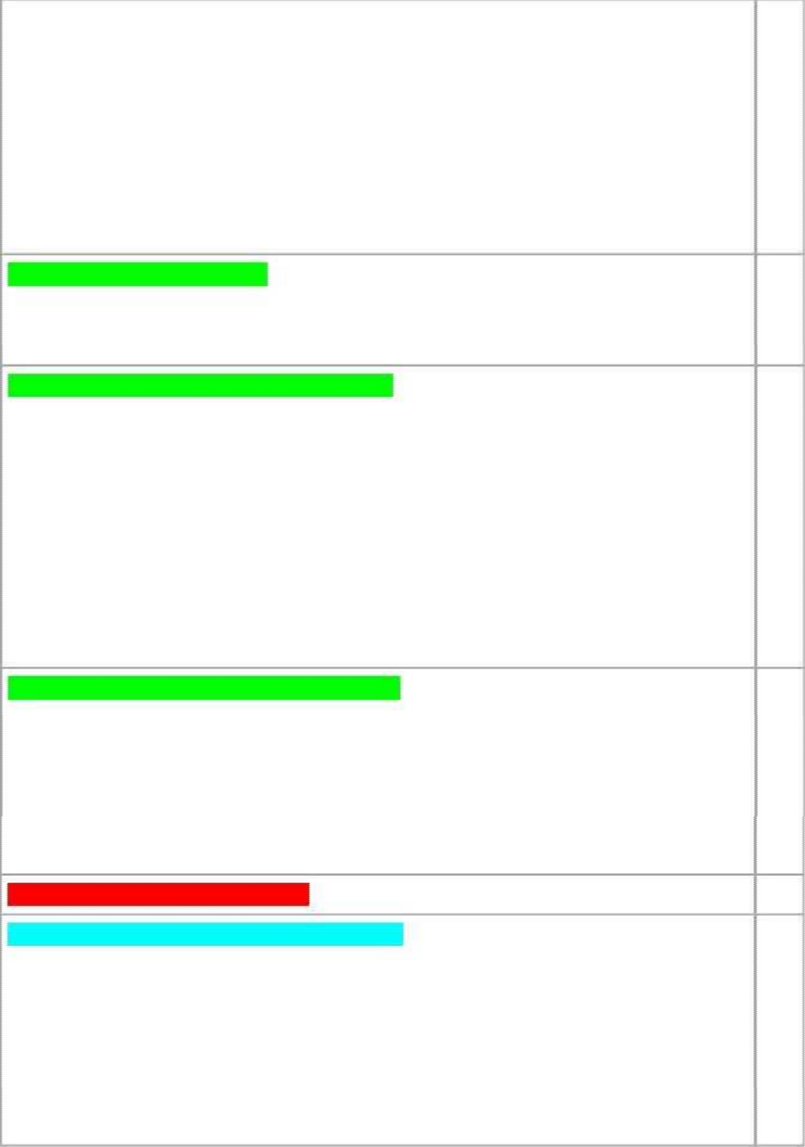
  - ,f their is a change pull that change 66666# calls the build script66666666666build it8 deploy it and test it6666and gives the feedback
  - (evelopers will made a change 666666666666
  - 0eedback is generated by &, server about the quality of code change666666666some thing bad he has done its available for him right away66666that is why continuous integration is so powerful6666
  - ,t integrates )&$ 666666,t integrates build and deployment systems666666and consolidate whole things # give a feedback on the quality of change666666666666it brings all systems together66666

What are the "rerequisites for &, G
we should have a pro.ect with your buildscript it might be wriCen in ant or it can be a maven too666
1nd we have to maintain a source repository666like svn8 git8 tfs etc66666666666

Which tool do you use for &,? 1nd how it works? I We use :enkins as a &, tool66666and coming to work process666666666666multiple developers are working on the pro.ect66666svn is the source repository which keeps the versioning of our les and maintaining our les data6666666and .enkins is the &, system which pole the source
repository and starts the build666so the build script is provided in 1n66666so8 it will execute the build script and it will generates the artifact666666
1rtifact is nothing but the output of our source code666 $o a<er compiling and packaging our source code the artifact will be generated666
$o once the artifact is generated from the given build script66666and we deploy the artifactsin to the tomcat server and then 1 guys will go for testing and validate it666and if there are any automated tests they can run and reports will be published from the .enkins dashboard or &, system dashboard66666666$o8 this is the process how .enkins works66666

What is the dierence between $)* and :enkins? /
$vn is .ust keep track of our source code versioning666666666666
-ut :enkins will manage the running builds and will manage your builds666so8 once we congure the pro.ect with .enkins 6666it will takecare of building it whenever changes happen in your source code and publish if any build failure or if there are any issues with the test cases666
$o8 as multiple developers working on the same source code beCer to integrate daily so that we can identify any dependency issues or any issues earliest666666666

What do
yo u m ean by
ru nning bu ilds? J


What kind of plugins you have installed and used? L 1ns =subversionBgit 8 cobetura8 clone8 email8 shelve8 .unit8 thin backup666these are the plugins
, have installed 6666666

,n the .enkins (ashboard le< side panel there is option manage .enkins ;;;K click on manage plugin ;;;K go to available option ;;;;K We can search for the plugin what we have to integrate with .enkins for ex= git we .ust type the git plugin in the lter option and it produces the git related plugins then we have to select it click on ,nstall with or without restart66666



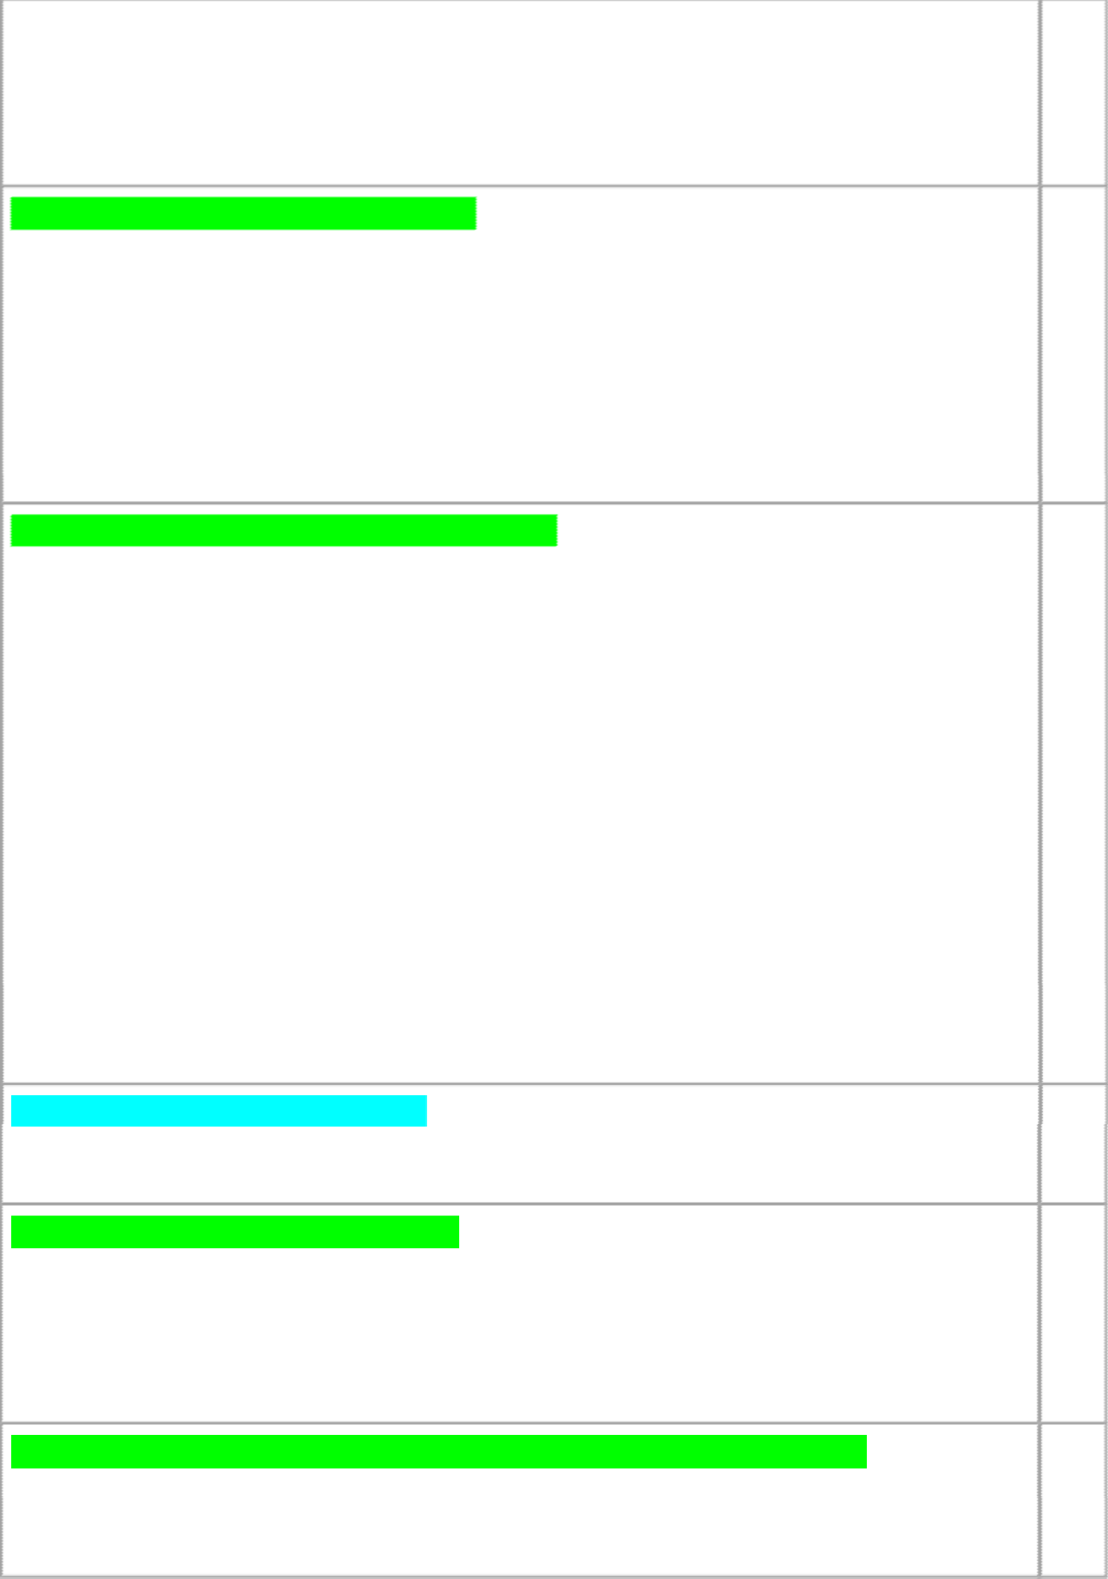-asically +it plugin have the dependencies also one is git client plugin and scm 1", plugin66 1<er installation it changes pending state to success state6666
1nd then once restart the .enkins and now we can congure the .ob6666

Have u create .enkins .ob from the scratch M
Aes66666-efore creating a .ob i will do some system conguration bc i have to congure the .dk subversion ant version details and path of that tools in the related sessions and i also congured the 2;mail notication session and so on666666and i will also install if any new plugins needed and a<er that i will create the .ob and i congured that .ob session and i trigger a build and i view console output and i send the status of the builds to the dev team66666

1ll the congurations of .enkins server will store in cong6xml le

Have u setup .enkins? How did you install .enkins? DO 0irst install .enkins and go to .enkins installed folder and copy .enkins war le and paste it in tomcat webapps6666

*ext type =
N :ava ;.ar .enkins6war N :enkins6rpm

1nd now go to tomcat path ;;;;Kls N cd bin
N chmod JJJ catalina6sh N sh startup6sh

*ow open browser type the default hCp=BBlocalhost=LOLO = then it will shows tomcat homepage
,f we want to open .enkins homepage= type hCp=BBlocalhost=LOLOB.enkins666666 hats it6666

How do you start .enkins as a service? DD
,nstall yum;;;;Kinstall .enkins6war

How do you start B stop Brestart a .enkins DE
0irst we have go tomcat installed path ;;;K bin ;;;;K
o start .enkins type= N sh startup6sh
o stop .enkins type= N sh shutdown6sh
1nd to restart type= stop the server and then start again666
,f we want to know whether .enkins server is in on or not= .ust type= ps ;ef P grep tomcat

How do you change your port no for your .enkins and what is the default port? D3 1ns= go to the tomcat installation folder and from there go to conf folder and open
service6xml there change the port 7connector5 to LOLD or any other port no from LOLO666and go to bin and double click on service6bat and click on sh startup6shB startup6bat and run



 .enkins on new port number666

Where do you nd default .enkins logs? DG
1ns= system log will captures the output from .ava6util6logging output related to .enkins66 select the 9system log9 from the 9>anage :enkins9 page=
0rom there8 you can create a custom log recorder8 which helps you group relevant logs together while ltering out the noise6

1 screen will open like log recorders;;;;;;K 1ll .enkins logs;;;Kclick on add new recorder;;;;K we have to chooseBenter the name that makes sense to us;;;;;;Kclick on ok
;;;Kand then we have to congure the logger details ex=hudson6plugin6diskQusage and select the log level to nd and click on add6666and click on save6666

Once the set up is complete, Jenkins will start collecting data. The collected logs are available from the web UI.

0rom RhCps=BBwiki6.enkins;ci6orgBdisplayB:2*S,*$B4oggingK

What are the chanllenges w ho have faced when s etting up .enkins DI

How do nd .enkins server is running or not? D/
1ns= go to console ;;;Kps ;ef P grep tomcat;;;;;K

then it will shows like=
UgeethaVlocalhost (esktopN ps ;ef P grep tomcat geetha 3OJI D O :ulOM ? OO=OD=GL BhomeBgeethaBso<waresBantQ.dkB.dkD6J6OQIDBbinB.ava
;(.ava6util6logging6cong6leXBhomeBgeethaBso<waresBapache;tomcat; L6O6EOBconfBlogging6properties
;(.ava6util6logging6managerXorg6apache6.uli6&lass4oader4og>anager
;(.ava6endorsed6dirsXBhomeBgeethaBso<waresBapache;tomcat;L6O6EOBendorsed
;classpath BhomeBgeethaBso<waresBapache;tomcat; L6O6EOBbinBbootstrap6.ar=BhomeBgeethaBso<waresBapache;tomcat;L6O6EOBbinBtomcat;.uli6.ar
;(catalina6baseXBhomeBgeethaBso<waresBapache;tomcat;L6O6EO
;(catalina6homeXBhomeBgeethaBso<waresBapache;tomcat;L6O6EO
;(.ava6io6tmpdirXBhomeBgeethaBso<waresBapache;tomcat;L6O6EOBtemp org6apache6catalina6startup6-ootstrap start
geetha 3LD/ 3JLO O OI=OG ptsBJ OO=OO=OO grep tomcat UgeethaVlocalhost (esktopN

How do you stop .enkins when some build .obs are in progress DJ

o restart :enkins manually8 you can use either of the following commands=
There is one option in jenkins; i.e., "preparing for shutdown" if any jobs



Ant: ant is test for java project, here there is no formal convention and no life cycle so entire project structure we mention in Build.xml file
Maven: maven is unit-test for java project, here there is formal convention and life cycle

- How dependeny !ana"e!ent in different Ant and Maven? How do you hand#e dependeny !ana"e!ent?
extremely important use case of “dependencyManagement” is the ontro# of versions of artifats used in transitive dependenies.

Generally dependency scope  types! a"compile
#"provided c"runtime d"test e"system f"import

$.How do you write usto!i%e tar"ets in Ant and Maven?
$target % and $&target %

&.How an you setup pro'y repository in Ant ( Maven?
Maven &conf&settings.xml
).an you different between *insta## and dep#oy+ in Maven?

install - install the pac'age into the local repository, for use as a dependency in other projects locally.
deploy - done in the #uild environment, copies the final pac'age to the remote repository for sharing with other developers and projects.

,.-here is Maven entra# 0oa# and e!ote epositories?

Maven #oa# repository: reside in the developer(s machine. )henever you run !aven "oa#s which re*uire these dependencies, maven will download the dependencies from remote servers and store them into developer(s machine.
By default, Maven create the local repository inside user home directory i.e. C:/Users/superdev/.m2 directory. +ou can change the location of the local repository in setting.xml file using localRepository tag.
Maven entra# repository: is located at http!&&repo.maven.apache.org&maven& . )henever you run bui#d ob, maven first try to find dependency from local repository. f it is not there, then, #y default, maven will trigger the download from this central repository location.




!aven re!ote repository: wor' exactly same way as maven(s central repository. )henever an artifact is needed from these repositories, it is first downloaded to developer(s local repository and then it is used.+ou can configure a remote repository in the /M file or super /M file in remote repository itself.

- where do you dep#oy artifats in to!at server? And where do you "et the artifats?
0omcat configuration is in the different folder. in windows 3. 1!23sers23ser2. Inte##i4Idea152system2tomcat2+our4pplication5ame

6. if i want re7dep#oy artifat8.war9 without de#etin"/undep#oy what you done/thin" in to!at?8ontent in !odu#e is different9?
1reate a temporary folder anywhere on the server lets say 6&var&tmp&war7images6. 0his will #e used to temporarily store uploaded images when deploying a new war
D6 1reate a folder to put new )48 file. lets say 6&var&tmp&war6
E6 1reate a shell script that do these things!
- 1opy all images from folder where user upload their images to the temp folder a#ove
- 9elete application folder in tomcat
- 9elete )48 file in tomcat
- 1opy new )48 file from point  to tomcat: folder
- 8estart tomcat ;to trigger the deployment"
- 1opy #ac' all images from point no.< #ac' to app folder newly created #y the deployment process

. i want dep#oy one artifats in to!at? And without usin" en;ins how to dep#oy the artifats in to!at sever?
15.how an you reate do;er i!a"e?
9oc'er #uild -t $image7name%

- how you reate do;er ontainer?
9oc'er run -ti =name $container7name% $present image7name% $storage location%


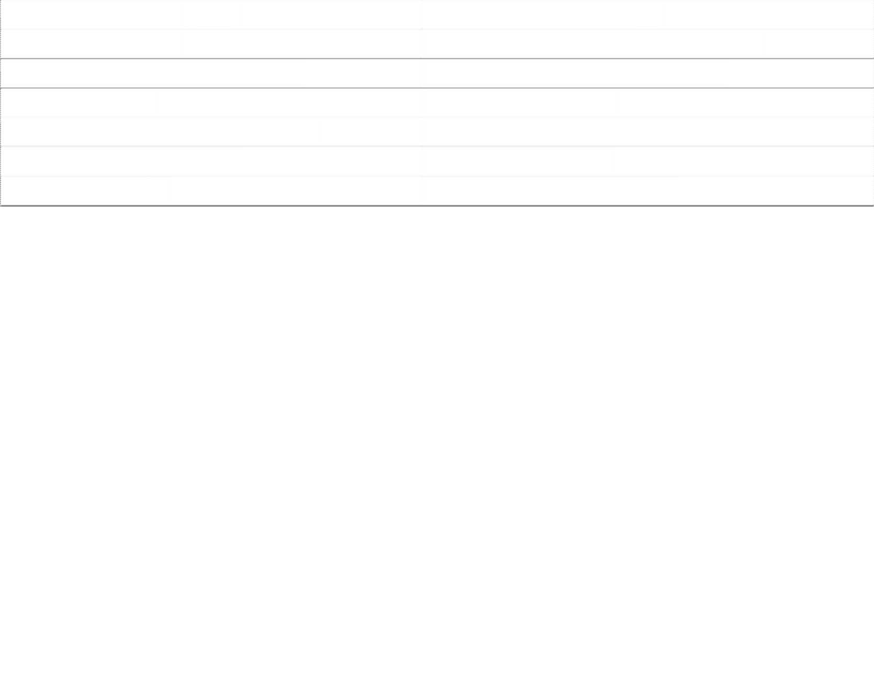

- how to onvert proet Ant to Maven?
1reate a pom with groupd, artifactd and version ;pac'aging! war"
D6 4dd the re*uired dependencies to the pom.xml
E6 move the
- ava soures to src&main&java,
- resoures to src&main&resources,
- webapp content to src&main&we#app,
- test content to src&test&java and src&test&resources
36 set the compiler compliance version using the !aven o!pi#er7p#u"in 1$. what is the advata"es of Ant and Maven?
Maven Ant
9escription of project 9evelopment of a #uild script per project
nvocation of defined goals ;targets" nvocation of project specific targets
roject ' nowledge 6>ust6 t he # uild p rocess #uild lifecycle, standard project layout too complex scripts reusa#le plugins, repositories scripts are not reusa#le
moving f ast f orward development a re s lowed d own

1&. what is adavanta"e of devops tea! in ora"ani%ation?
0ime ta'en very less
1).have you wor;ed on any other <S?
no
1,.te## !e differene b/w "it and other vs? Git is distri#uted version control system cvs&svn is central version control system
- what is "it branhin" strate"ies in your or"ani%ation?
?uppose we have two #ranches first #ranch you add the roject<.@ and in same rojects done some modification&updates that is roject.@ add to Branch, if do this thing merge the two #ranch we will not get the conflict so we can easy to implement the updated versions very easy.
16.what is "it stash?




+our are wor'ing on one #ranch you have urgent re*uirement to another project you don(t save the data #y using git stash we can save the data temparory.
1.how do you retrieve the ontent in "it stash?
“git stash apply index”
25.if you usein" "it stash where wi## it save data?what is diff b/w inde' and sta"in" area?
“Inde' area” save the data A essentially a 6holding area6 for changes
Sta"in" is a step #efore the commit process in "it.

- what is best reso#ve in onf#it in !er"e "it?
?ometimes you get merge conflicts when merging or pulling from a #ranch. Git will then tell you something li'e 1/5C10 ;content"! Merge conflict in a'efile. t also tells you to fix the conflicts and then to commit the
git config glo#al merge.conflictstyle diffD

- where is =estin" >iture is o!!in" in ev@ps?
By using #uild-tools li'e maven, ms-#uild unit test come to picture

2$.what is do;er o!pose?
0o run the containers at a time A connection #&w multiple application server lin' with on 9B doc'er-compose.yaml
doc'er-compose.up d

2&.what type of proets your wor;in"?
0elecom

2).what are the different types of H==> reuest !ethods?
GE0, 30, FE49, 9ECE0E, /0/5?
GE0 is usually intended to retrieve some data, and is expected to #e idempotent




30
FE49 9ECE0E

2,.how do you "enerate the own SS07ertifats?
nstall mod-ssl
openssl genersa @: % $ssss.pem%
give certificate validation DH days or ID@ days edit lisiner in load #alancer
paste in private 'ey

- how to n"in' as a pro'y?is it possib#e?
BCIBD is a free, open-source, high-performance F00 server and reverse proxy, as well as an
M4&/D proxy server.
)e can configure nginx as a proxy
5odeBB #y default runs on port HI, meaning that #uilds are usually accessed using a port num#er in addition to their hostname ;e.g. http!&&example.org!HI"
n order to allow 5odeBB to be served without a port, nginx can #e set up to proxy all re*uests to a particular hostname ;or su#domain" to an upstream 5odeBB #uild running on any port.

26.what is your frant7end and ba;7end servies?
ront-end! CoadBalancer li'e 5ginx and 4pache. Bac'-end! 9ataBase li'e My?*l-9B, /racle-9B.

2. suppose your do!ain srinivasarao.o! by defau#t it wi## "o http//srinivasarao.o! how do you rediret the http//srinivasarao.o!?
F00 allows servers to redirect a client re*uest to a different location. 4lthough, this will usually result in another networ' round trip, it has some useful applications.



)6.Maven arhetypes?
Fere are the most popular archetypes in Maven
D6 Uuic' ?tart
E6 )e# app
Below command will create a sample project using *uic' start archetype. 5ote that dou#le
*uotes around the parameter values are re*uired if you are executing #elow command using window command prompt or windows owershell.
!vn arhetype:"enerate 7"roupId+or".softpost+ 7artifatId+MyStandardApp+ 7arhetypeArtifatId+!aven7arhetype7ui;start+ 7interativeMode+fa#se+
Below command will create a sample project using web app arhetype.
!vn arhetype:"enerate 7"roupId+or".softpost+ 7artifatId+My-ebApp+ 7arhetypeArtifatId+!aven7arhetype7webapp+ 7interativeMode+fa#se+

). e#ear Maven ependany?
or example = if you want to run 4nit tests, you will have to define #elow >3nit dependency in your /M.xml
JdependenyK
J"roupIdKunitJ/"roupIdK JartifatIdKunitJ/artifatIdK JversionK&.12J/versionK J/dependenyK
4ll right = so we declared the dependency in /M.xml now what nextV
+ou don(t need to do anything apart from declaring the dependency. Maven will ta'e control from there and get the >3nit artifact for you.
f you are not sure which version of >3nit to use, you can visit http!&&mvnrepository.com& and find out the group name, artifact name and version for >unit.
,5. Addin" in .ar/.war/.ear fi#e in dependany !aven?
dependency%
$groupd%org.softpost$&groupd%
$artifactd%a#c$&artifactd%
$scope%system$&scope%
$version%<.I$&version%
Jsyste!>athKLbasedirNOsrO#ibOab.arJ/syste!>athK



$&dependency%

,1. Maven p#u"7ins?

Maven plug-ins can #e divided into  types.

D6 bui#d = Build plugins should #e included in $#uild% tag. Build plugins are executed during #uild process.
E6 reportin" = 8eporting plugins should #e included in $reporting% tag. 8eporting plugins
are executed during site generation once the #uild process is complete. or example =
javadoc and surefire-report are reporting plugins.
lug-ins can also #e categoriNed in #elow way.
D6 1ore ;Most fre*uently used ones" = clean, compiler, surefire, deploy, install, resources, site
E6 ac'aging ;3sed for pac'aging the project artifacts"= jar, war, ear
$. eportin" P avado
G6 0ools ;used for performing tas's other than #uild process" = ant, archetype, help, release Fere is the list of some of the most popular plug-ins and their associated goals in maven.
D6 compiler!compile = compiles project
2. arhetype:"enerate P reates new proet
36 surefire!test G6 clean!clean I6 deploy
/6 install
J6 resources
L6 site
M6 verifier DO6 jar DD6war DE6 avado
D36surefire-report
,2. !aven Surefire p#u"7in onfi"uration?

onfi"uration of surefire p#u"in

D6 suiteD!#i#e = specify the xml file containing tests to #e executed
E6 "roups = specify the group names to #e included. 0ests #elonging to those groups will #e executed.




36 G'#uded"roups = specify the group names to #e excluded. 0ests #elonging to those groups will not #e executed.
G6 para##e# = f you want to execute tests in parallel, use this tag. ossi#le values for this tag
can #e methods, classes
I6 threadount = Fow many threads should #e created at a time to execute testsV Fere is the sample configuration of surefire p#u"in
$plugin%
$groupd%org.apache.maven.plugins $&groupd%
$artifactd%maven-surefire-plugin $&artifactd%
$version%.<.<$&version%
$configuration%
$suiteWmliles%
$suiteWmlile%testng.xml$&suiteWmlile%
$&suiteWmliles%
$groups%sanity, regression$&groups%
$excludedgroups%smo'e$&excludedgroups%
$parallel%methods$&parallel%
$thread1ount%D$&thread1ount%
$&configuration%
$&plugin%

,$. where is Ansib#e 0o" fi#es are stored?

&etc&ansi#le&ansi#le.cfg

,&. where is en;ins #o" fi#es stored?

,). where is #inu' #o" fi#es are stored?

/var/log

. where maven #uild artifacts storedV

.m folder

I. how to run maven ofline pac'agesV Maven o pac'age.
oPofline

,6. what is diff b/w version and snapshot?

?napshot! it will ta'e latest version




version! what you mensations it will ta'e only that version

,3. what are the !aven p#u"7ins? 8epository plug-ins! siNe related plug-in #uild plug-in! execute during #uild
report plug-in

,6. what is * G'terna# ependany+ onept in !aven?

0here is no&not dependancy in maven repository ;local&central&remote repository" use external dependancy.

,3. is ansib#e para##e# e'eution 8or9 seuentia# e'eution?

4nsi#le is a #y default parallel execution, ansi#le nting #ut control machine it can execute 5- num#er of nodes, when ever you mensation serialP< mensation in play#oo' it will act as se*uential execution.

4nsi#le play#oo' is se*uential execution we give install sevice, start the application these are
se*uential execution

,6. Ansib#e is orhestration too# how do you estify? hat about puppet?

?ervice are orchestrated...

puppet is not orchestration, #ut puppet enterprice is orchestration.

,. how to he; the o/p e'eute 8or9 not in ansib#e and puppet?

)hen you run the play#oo', lastly show ing ong ;j-son format" state are chaged o&p come
state is not chage o&p not come

- i want run e2 instane other then CI?

4ws cli teraform
jen'ins amaNon ec plug-ins



through ansi#le ;#y using play#oo'"
through python script

0O;:9
n pre%ious $ays !e use$ p"ysical ser%ers to $eploy applications

*ra!backs:-

+. ,nuse$ resources(ram cpu "$$)
. Costly to buy ser%ers
/. &pace consuming

0ater came %irtual tec"nology !"ic" sa%e$ money an$ optimie$ resources

*ra!backs:-

+. Eac" %m !ill "a%e copy of o.s files !"ic" makes booting slo!
. %m "ar$ $isk sie is too large an$ $ifficult to mo%e bet!een en%ironments
/. Performance $o!n
1. 2e nee$ to pro%i$e %irtual mot"erboar$ cpu ram etc...
3. E%ery app rely soon guest o.s not on "ost o.s

No! came container tec"nology !"ere containers s"are "ost o.s kernel

%m means %irtual mac"ine !"ic" "as o.s bin#lib files an$ on top !e install applications 'ust like t"at container is a mac"ine#box !"ere t"ere !ill be bin#lib files an$ applications
in 45!are !e can create +3-6 %ms 'ust like t"at in $ocker !e can create as many as containers !e nee$
n bare metal installation !e install "ost o.s (2#0) on top !e install %irtual mac"ine soft!are (7ypr#Esxi) an$ !e create %m8s in eac" !e install guest o.s an$ on top !e install apps
n a ser%er !e install "ost o.s (0inux) an$ $ocker engine is installe$ no! !e can create as many containers as possible. n eac" container !e "a%e apps bins libs. 9ll t"e apps#containers s"are kernel o.s



enefits:-

+. Portability
. &tability
/. oot time is fast
1. solation ; e%ery app !orks in its o!n container n $on8t interfere ot"er aps

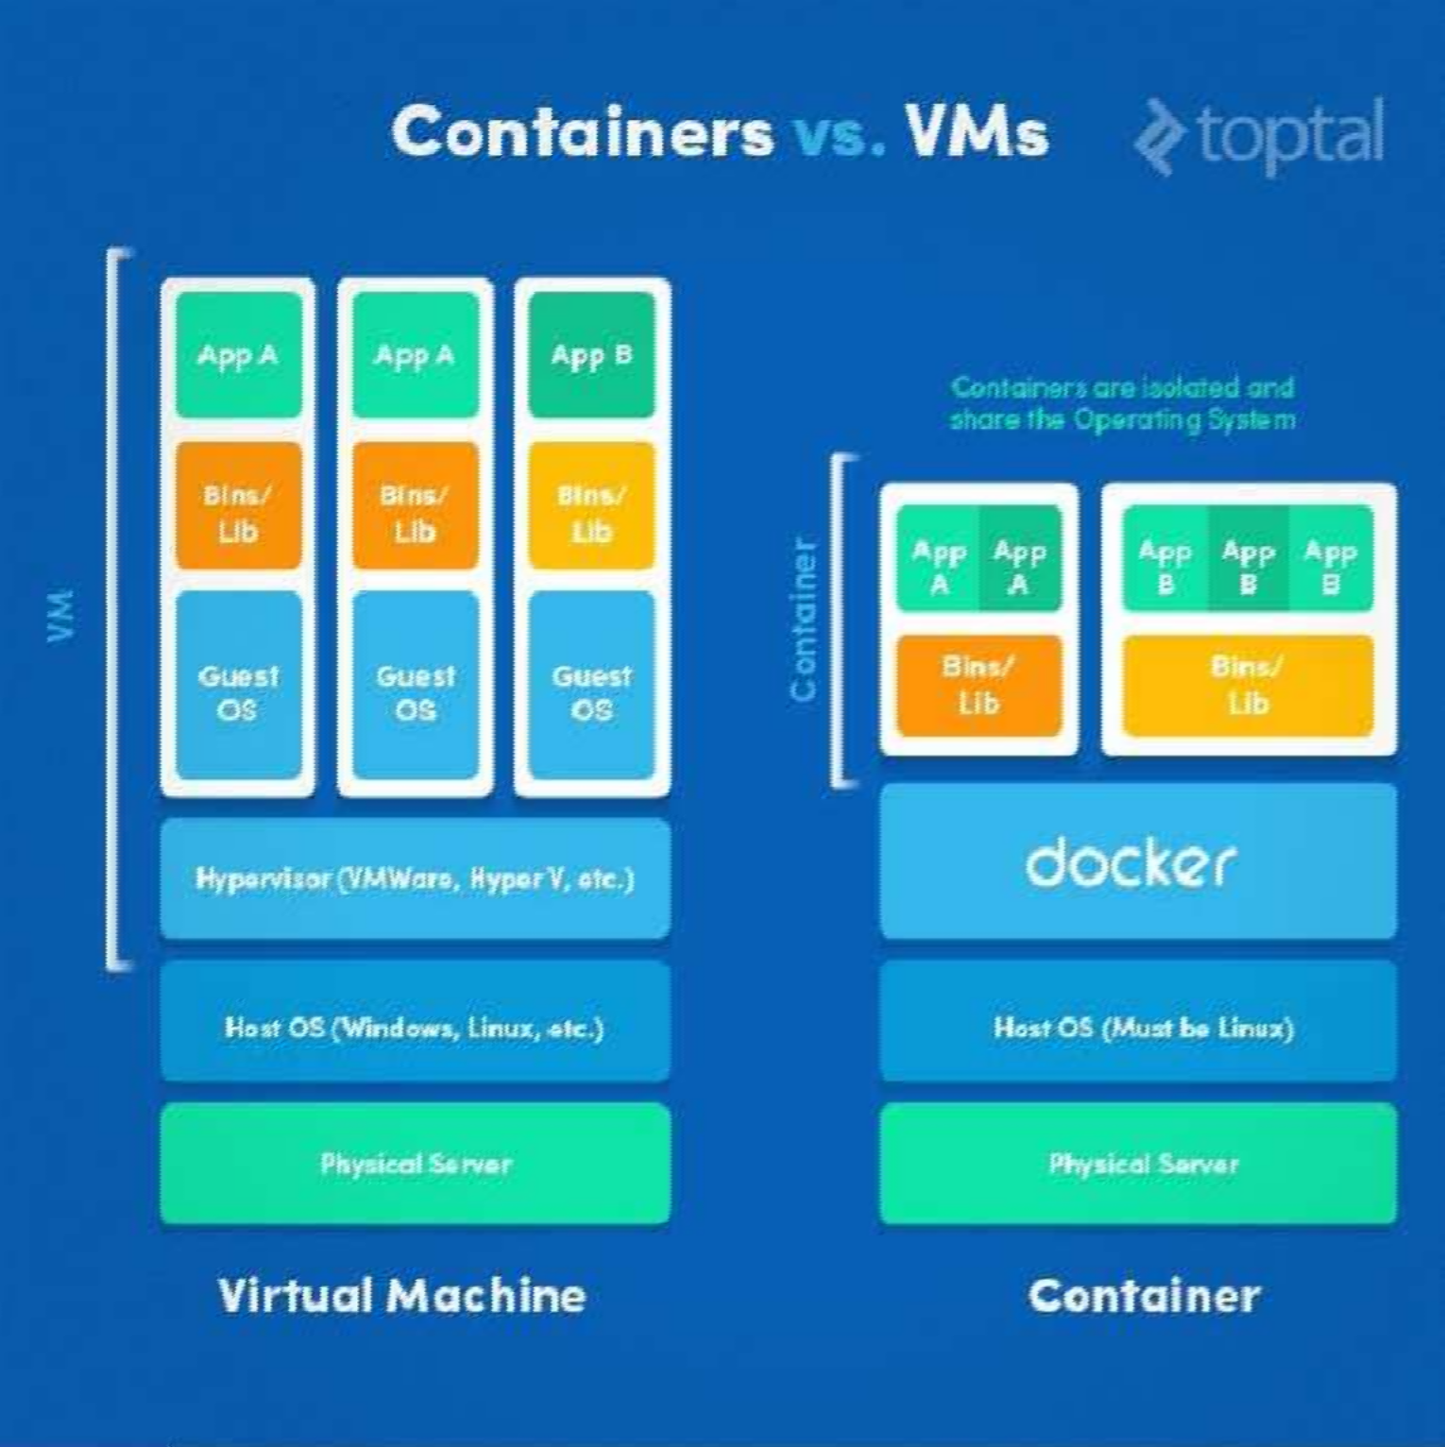




  - "lease check if the $1* ask which is .ust the storage task `4ook at server7name5 to see why we cant communicate on the network?check if someone 7name5 has a $1* ask and $0 in the build Work order`, dont even see a build Work !rder in the factory record so we might need one opened 1$1" and progress`
  - WoDDJJ` is the work order that has been created for a server7name5since the server has
network issue 8, have not advanced the tasks `please send your other email to 7name5 regarding the network issue on the server
  - 2mail= Hi 7name58 his server is not coming on the network`looks like ethE and eht3 are cabled
but we are unable to ping the default gateway8can you please have the switch post conguration checked
  - I6*1$ storage request created
  - $ummary=,mplementation W," $torage over IOO +-
  - &'$Q*1$Qequest 0ormQservername6xls is the form aCached 8server and storage7E types`
$1*8*1$5 required
  - G- of $1* `0ile $ystem created
  - /6High space used for a5Bvar le system b5Btmp le system c5Broot le system
  - /6We will be doing a world writable scan next week end and need to have all 4inuxBH";' B1, 1gents online H";' 1nd 1ix are well maintained 64inux requires some cleanup
  - -asic`4inux !$ $upport
  - (escription=, am particularly concerned about the agents that have been oine for more than a
week 8but we need the 4inux 1gents to be online as we are required to have world writable les checked on DOO  of servers 6,f they are decommissioned6they need to be cleared or , need a list6$o , can account for why there are no results for that server6"lease see aCachment for more detail7start a particular service 7online agent5 that is not running
  - &omputer name last report time
  - `````````6 ;;;;;;;;;;;;;;;;;;
  - *ote=(2$ 1gent is a service to determine world7others 66i6e anybody can have access to this box5 writable les
  - J6hel / to hel J upgrade`i6e upgrade a box from hel / o helJ
  - L6$erver build request 7o ,nstall !$ on a new -ox56
  - his particular request 70$56
  - ,nformation given is `6*ew Host to install_," 1ddress of that host _,4! ," 1ddress_2very machine will have id no67serial no65_1sset tag`not related to !$Bbox itself6
  - M6+enesys servers`*" osets
  - DO64inux $erver "atching=4ist of servers7+-( servers5 to do patching7patched5 and rebooted6
  - $ub.ect=put change ticket no6 for patching
  - 2g=Hi *ame8
  - he following servers will be patched7connect to servers5 and patched6
  - ecipient $ub.ect
  - *ame e="atch &ontenders received so far for & &H+ ODDDDJ37"!( servers `hence onlypatch the ones in +reen5




  - 1<er completion of patching8give an email saying that server patching is complete and servers are back up and running`so please 1a'i(at!/W2at (+ y+ !a" y 1a'i(at!
  - DD6(escription=, am particularly concerned about the agents that have been oine for more than a week8but we need all 4inux agents to be online8we are required to have world writable
les checked on DOO  of the servers 8if they are decommissioned they need to be cleared or , need a list so that can account for why there are no results for that server6"lease see aCachment for more detail6
  - $ummary=We will be doing a world writable scan next weekend and need to have for all 4inuxBH";'B1ix 1gents online6Hp;'x and 1ix are well maintained64inux requires some clean up6
  - ,2> 7product52> besclient reinstall
  - -esagent7package installed5 is a service to nd world writable les`write permissions are given to owner and to group`6still you wont be able to edit it6
  - DE6steps=
  - D6stop application and shut down the database
  - !$ "atchingBreboot74inux5
  - elink !racle 4ibrary7(-15
  - eset 4ibrary "ermisions74inux5
  - $tart up (atabase7(-15
  - $tart application72>5
  - 0ind out what will get updated on the boxes and print those packages that will get updated6
  - D36,ssue for account lockout for enetlbv because of failed buildforge .obs`therefore please update the password in -uildforge6
  - DG6server name`$rc=,>+ "rocess missing=init
  - $erver name=$rc=,>+ "rocess missing auditd
  - DI6How do , disable kaudit6d on 0e`6,t wont allow to start the service or stop6
  - D/6!n each of E servers , need a Baxway le system of sie G - and exported as *0$ 6&reate a G
- on *1$ device
  - &hange icket=1s per the requested *1$ task6, have mounted temporarily on below mentioned servers 6"lease mount permanently and close the change ticket task 6
  - Sindly mount the 4inux servers for the below share and complete the respective task in the change &H+OOM/JJ
  - >aDL`67servername5 BvolQ1xway 66share is the *0$ share that was created on *1$ device Bappliance for a sie of G -
  - DJ6"erforming a change request =
  - Sernel parameter8888fs6aioQmax6nr needs to be set to 3DGIJE/ as per !racle
ecommendation62xecute sysctlQp to force a reload of the conguration6his needs to be done on servernameD and servernameE6
  - DL6"atching=ime to time servers will get updated and you have to schedule an export and since
these servers are db servers 8they have to coordinate with (-1 who will stop the database ` 4inux people will do patching8 report the box once the server is up and running 6




  - ,ssue=We have to identify in a preview mode if , run the Aum &ommand 8what will get updated on these boxes7servers5 .ust tell us and not print`pass the list 8he will look at what all packages are getting updated on these boxes7servers5 and he will decide whether it updates his dbBnot6
  - ,ssue="lease provide the details of !$ "atching 7"> 41 8anything else5so that , can open an
!racle $ to check the impact Bcompatibility of the (- version
  - DM6>aintenance steps=
  - $!" H2 1""4,&1,!* 72>5
  - $H' (!W*7(-15!$ "1&H,*+B2-!!74,*'5
  - 24,*S !1&42 4,-1A7(-15
  - 2$2 4,-1A "2>,$$,!*$74,*'5
  - $1,*+ (-7(-15
  - $1 1""4,&1,!*72>5
  - "lease nd the list of packages that get updated for the respective servers`serverD8serverE``
  - "lease be aware that we are still missing E mef3 les from E 4inux servers to supply with the
customer les that is done by 2!- on `7date561 &irate will be opened if the les are not received by 2!- tomorrow
  - EO6*eed to mount the *1$ server nameBvolQwccQtest to the 4inux servers with mount point name volQwccQtestQ6666, have created user ```6and group``` on these servers
  - ED6*etwork le systems=
  - &hange ticket=,nstall so<ware then deploy application Bmaking changes on the production
box_create a change and then renew by change management team what the change is about ` all information is entered in the change ticket
  - EE6service request=&an you mount *1$ shares `i6e sharing the *1$ drives to the "!( $ervers
  - *1$ +uys will export a le system for all 4inux $ervers
  - equest=2xport *1$ volume onto which server
  - , tried a couple of servers and got permission denied while trying to mount Bstellent content6,t looks like its the permission issues on the storage side 6&an you please make sure that the *1$
eam has processed the request for these servers
  - E36"lease go and create an nameD folder under BnameE for the remaining server7creating a directory on these servers earlier it gave permission denied but now , have to retry5
  - EG6,n a server , requested a service 6How to change the log level in a centrify dc 6conf le to
W1*6,t was set to (2-'+6*ot that this should aect &entrify should work but would cause increase logging for centrify and later on create space issues8once done centrify (c service service will be restarted
  - ,ssue= , wanted to bounce &entrify (& service but before that , changed the 4og in &entrify dc6conf le to W1* 6it was not set to (2-'+
  - EI6How to remove the old kernel?What do you mean by )ulnerability list?
  - E/&hange ask=4inux :ar >igration changes6pression6:arle needs to be updated to "roduction
:ar server 4ibrary8also properties les needs to be updated as per new pression webservice '4




- EJ6We are unable to use sudo su wsadmin command in server 7name 5due to the network errors _so<ware caused connection abort _please check this and let us know once it is xed6
- EL6*ew batch server setup in "20 and "!( (iscussions6
- EM6How to restart agents on server7name5?How to do agents installing on server7names5?
- How to unlock and reset password on server7names5?
- 3O6&hange tasks for non production servers_emediation of oine ivoli >onotoring agents_0or each of the hosts he wants me to start and stop the agent7ivoli >onitoring $ervice5
- 3D6"lease initiate )erication "ost ,mplementation "rocess
- 2= *ew -atch $erver setup in "20 and "rod (iscussions
- *otes= $etting up space in -atch $erver
- &ontrol > 1gent ,nstallation
- !racle and :ava setup
- 1ction items=
- $pace;;;;*eed to submit $8efer equest , from the category in which request has to be submiCed
- &ontrol 1gent ,nstallation
- !racle and :ava setup=*eed to get the details from mid range techsupport on servernameD and servernameE and share it with 4inux team so that it can be setup the same way

